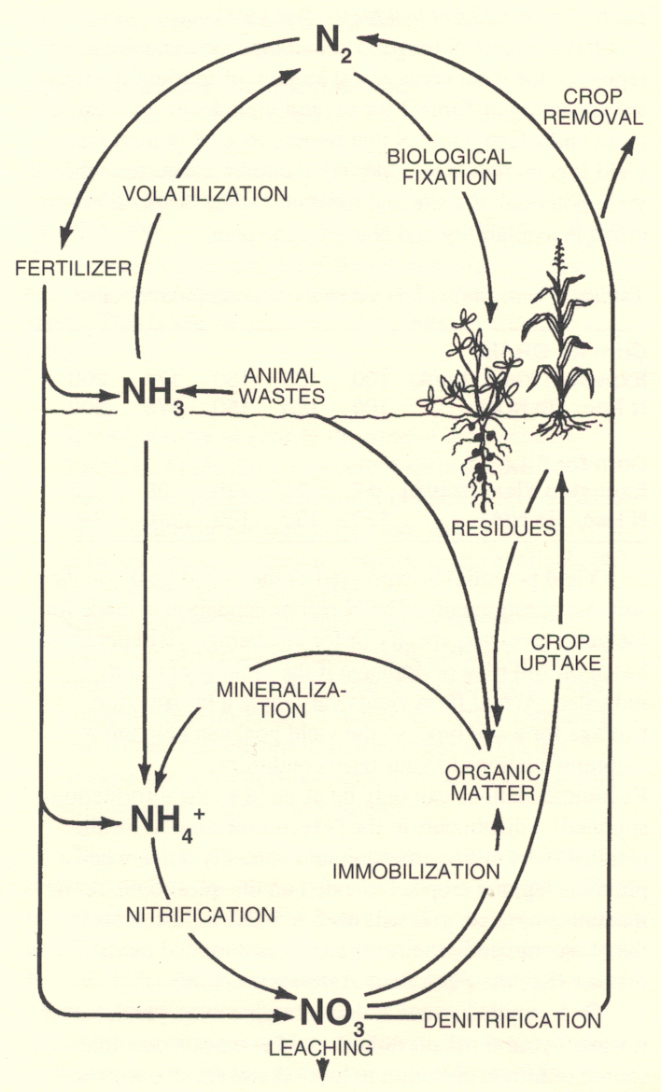
What type of crop is this?
What conditions are best for mineralization?
Can corn do biological N fixation?
Which soils are more prone to N losses via denitrification?

Poorly drained or well drained?

How can we manage animal wastes to reduce NH₃ volatilization?
1.

2.
Which soils are more prone to N losses via leaching?

Poorly drained or well drained?

What percent of the atmosphere is N₂ gas?
What is this molecule called?
What is this molecule called?
What is this molecule called?
What is this molecule called?
From Penn State Agronomy Facts 12

N Cycle Notes:

